Linux Top 50 Commands

The following are the top 50 Linux commands:

Linux Directory Commands

**1. pwd Command**

The [pwd](https://www.javatpoint.com/linux-pwd) command is used to display the location of the current working directory.

**Syntax:**

1. pwd

**Output:**

Linux Commands with Examples

**2. mkdir Command**

The [mkdir](https://www.javatpoint.com/linux-mkdir) command is used to create a new directory under any directory.

**Syntax:**

1. mkdir **<directory** name**>**

**Output:**

Linux Commands with Examples

**3. rmdir Command**

The [rmdir](https://www.javatpoint.com/linux-rmdir) command is used to delete a directory.

**Syntax:**

1. rmdir **<directory** name**>**

**Output:**

Linux Commands with Examples

**4. ls Command**

The [ls](https://www.javatpoint.com/linux-ls) command is used to display a list of content of a directory.

**Syntax:**

1. ls

**Output:**

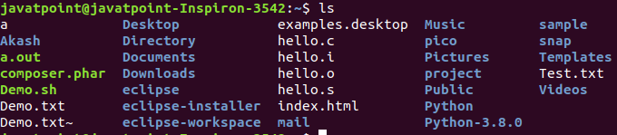

**5. cd Command**

The [cd](https://www.javatpoint.com/linux-cd) command is used to change the current directory.

**Syntax:**

1. cd **<directory** name**>**

**Output:**

Linux Commands with Examples

Linux File commands

**6. touch Command**

The [touch](https://www.javatpoint.com/linux-touch) command is used to create empty files. We can create multiple empty files by executing it once.

**Syntax:**

1. touch **<file** name**>**
2. touch **<file1>**  **<file2>** ....

**Output:**

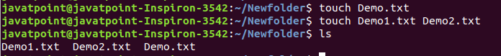

**7. cat Command**

The [cat](https://www.javatpoint.com/linux-cat) command is a multi-purpose utility in the Linux system. It can be used to create a file, display content of the file, copy the content of one file to another file, and more.

**Syntax:**

1. cat [OPTION]... [FILE]..

To create a file, execute it as follows:

1. cat **>** **<file** name**>**
2. // Enter file content

Press "**CTRL+ D**" keys to save the file. To display the content of the file, execute it as follows:

1. cat **<file** name**>**

**Output:**

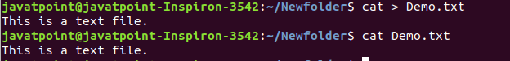

**8. rm Command**

The [rm](https://www.javatpoint.com/linux-rm) command is used to remove a file.

**Syntax:**

rm <file name>

**Output:**

Linux Commands with Examples

**9. cp Command**

The [cp](https://www.javatpoint.com/linux-cp) command is used to copy a file or directory.

**Syntax:**

To copy in the same directory:

1. cp **<existing** file name**>** **<new** file name**>**

To copy in a different directory:

**Output:**

Linux Commands with Examples

**10. mv Command**

The [mv](https://www.javatpoint.com/linux-mv) command is used to move a file or a directory form one location to another location.

**Syntax:**

1. mv **<file** name**>** **<directory** path**>**

**Output:**

Linux Commands with Examples

**11. rename Command**

The [rename](https://www.javatpoint.com/linux-rename) command is used to rename files. It is useful for renaming a large group of files.

**Syntax:**

1. rename 's/old-name/new-name/' files

For example, to convert all the text files into pdf files, execute the below command:

1. rename 's/\.txt$/\.pdf/' *.txt

**Output:**

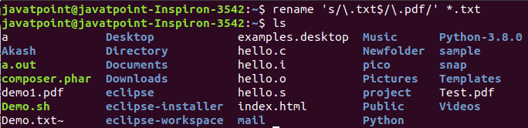

Linux File Content Commands

**12. head Command**

The [head](https://www.javatpoint.com/linux-head) command is used to display the content of a file. It displays the first 10 lines of a file.

**Syntax:**

1. head **<file** name**>**

**Output:**

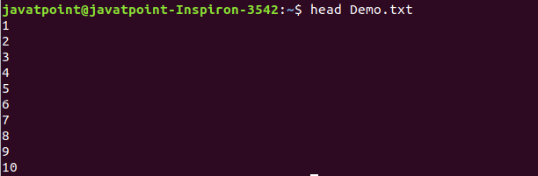

**13. tail Command**

The [tail](https://www.javatpoint.com/linux-tail) command is similar to the head command. The difference between both commands is that it displays the last ten lines of the file content. It is useful for reading the error message.

**Syntax:**

1. tail **<file** name**>**

**Output:**

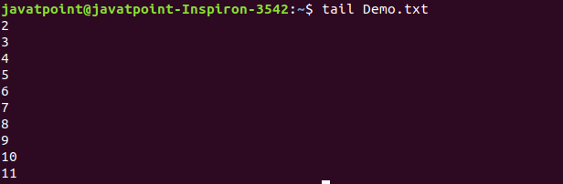

**14. tac Command**

The [tac](https://www.javatpoint.com/linux-tac) command is the reverse of cat command, as its name specified. It displays the file content in reverse order (from the last line).

**Syntax:**

1. tac **<file** name**>**

**Output:**

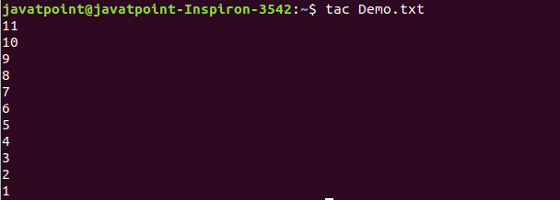

**15. more command**

The [more](https://www.javatpoint.com/linux-more) command is quite similar to the cat command, as it is used to display the file content in the same way that the cat command does. The only difference between both commands is that, in case of larger files, the more command displays screenful output at a time.

In more command, the following keys are used to scroll the page:

**ENTER key:** To scroll down page by line.

**Space bar:** To move to the next page.

**b key:** To move to the previous page.

**/ key:** To search the string.

**Syntax:**

1. more **<file** name**>**

**Output:**

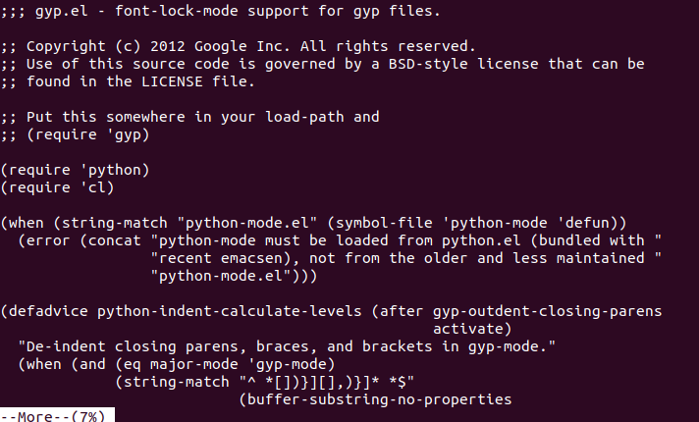

**16. less Command**

The [less](https://www.javatpoint.com/linux-less) command is similar to the more command. It also includes some extra features such as 'adjustment in width and height of the terminal.' Comparatively, the more command cuts the output in the width of the terminal.

**Syntax:**

1. less **<file** name**>**

**Output:**

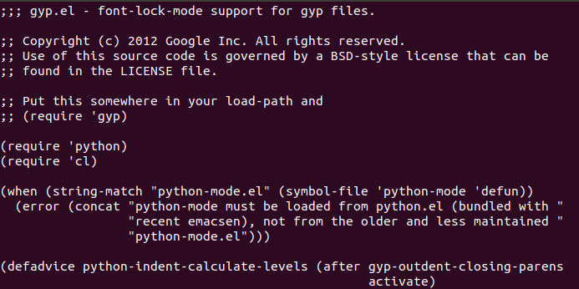

Linux User Commands

**17. su Command**

The [su](https://www.javatpoint.com/linux-su-commands) command provides administrative access to another user. In other words, it allows access of the Linux shell to another user.

**Syntax:**

1. su **<user** name**>**

**Output:**

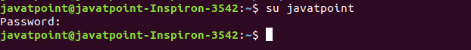

**18. id Command**

The [id](https://www.javatpoint.com/linux-id-command) command is used to display the user ID (UID) and group ID (GID).

**Syntax:**

1. id

**Output:**

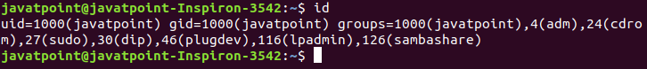

**19. useradd Command**

The [useradd](https://www.javatpoint.com/linux-create-user) command is used to add or remove a user on a Linux server.

**Syntax:**

1. useradd  username

**Output:**

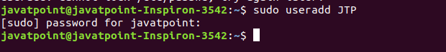

**20. passwd Command**

The [passwd](https://www.javatpoint.com/linux-user-password) command is used to create and change the password for a user.

**Syntax:**

1. passwd **<username>**

**Output:**

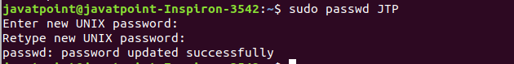

**21. groupadd Command**

The [groupadd](https://www.javatpoint.com/linux-add-user-to-group) command is used to create a user group.

**Syntax:**

1. groupadd **<group** name**>**

**Output:**

Linux Commands with Examples

Linux Filter Commands

**22. cat Command**

The [cat](https://www.javatpoint.com/linux-cat-filters) command is also used as a filter. To filter a file, it is used inside pipes.

**Syntax:**

1. cat **<fileName>** | cat or tac | cat or tac |. . .

**Output:**

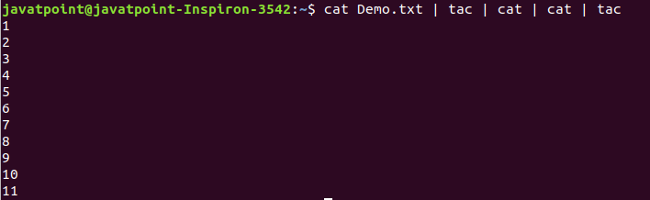

**23. cut Command**

The [cut](https://www.javatpoint.com/linux-cut) command is used to select a specific column of a file. The '-d' option is used as a delimiter, and it can be a space (' '), a slash (/), a hyphen (-), or anything else. And, the '-f' option is used to specify a column number.

**Syntax:**

1. cut -d(delimiter) -f(columnNumber) **<fileName>**

**Output:**

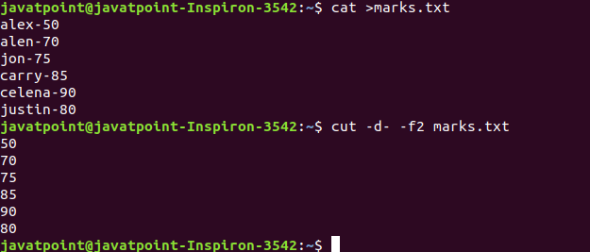

**24. grep Command**

The [grep](https://www.javatpoint.com/linux-grep) is the most powerful and used filter in a Linux system. The 'grep' stands for "**global regular expression print**." It is useful for searching the content from a file. Generally, it is used with the pipe.

**Syntax:**

1. command | grep **<searchWord>**

**Output:**

Linux Commands with Examples

**25. comm Command**

The ['comm'](https://www.javatpoint.com/linux-comm) command is used to compare two files or streams. By default, it displays three columns, first displays non-matching items of the first file, second indicates the non-matching item of the second file, and the third column displays the matching items of both files.

**Syntax:**

1. comm **<file1>** **<file2>**

**Output:**

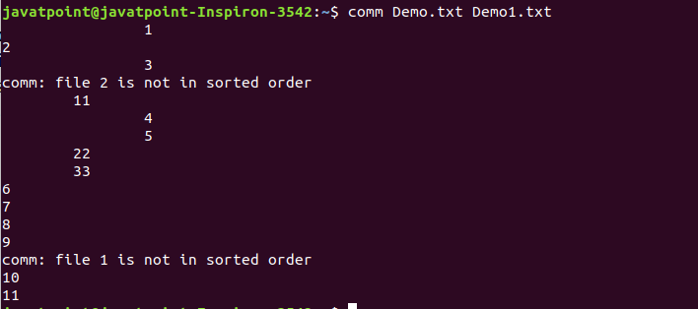

**26. sed command**

The [sed](https://www.javatpoint.com/linux-sed) command is also known as **stream editor**. It is used to edit files using a regular expression. It does not permanently edit files; instead, the edited content remains only on display. It does not affect the actual file.

**Syntax:**

1. command | sed 's/**<oldWord>**/**<newWord>**/'

**Output:**

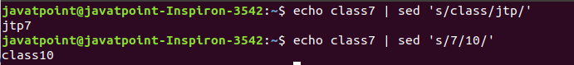

**27. tee command**

The [tee](https://www.javatpoint.com/linux-tee) command is quite similar to the cat command. The only difference between both filters is that it puts standard input on standard output and also write them into a file.

**Syntax:**

1. cat **<fileName>** | tee **<newFile>** |  cat or tac |.....

**Output:**

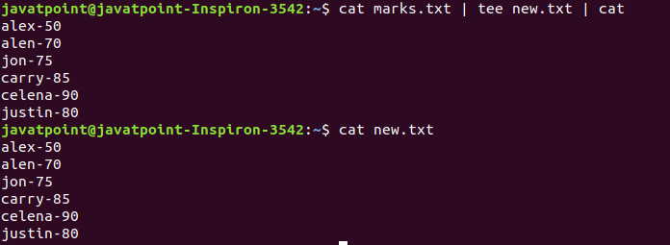

**28. tr Command**

The [tr](https://www.javatpoint.com/linux-tr) command is used to translate the file content like from lower case to upper case.

**Syntax:**

1. command | tr **<**'old'**>** **<**'new'**>**

**Output:**

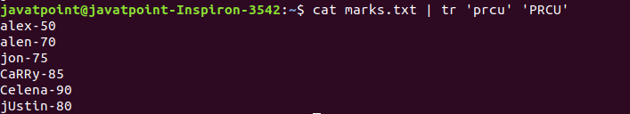

**29. uniq Command**

The [uniq](https://www.javatpoint.com/linux-uniq) command is used to form a sorted list in which every word will occur only once.

**Syntax:**

1. command **<fileName>** | uniq

**Output:**

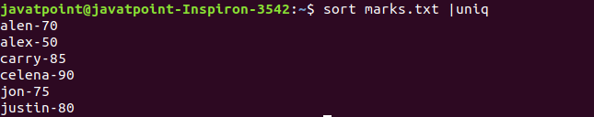

**30. wc Command**

The [wc](https://www.javatpoint.com/linux-wc) command is used to count the lines, words, and characters in a file.

**Syntax:**

1. wc **<file** name**>**

**Output:**

Linux Commands with Examples

**31. od Command**

The [od](https://www.javatpoint.com/linux-od) command is used to display the content of a file in different s, such as hexadecimal, octal, and ASCII characters.

**Syntax:**

1. od -b **<fileName>**      // Octal format
2. od -t x1 **<fileName>**   // Hexa decimal format
3. od -c **<fileName>**     // ASCII character format

**Output:**

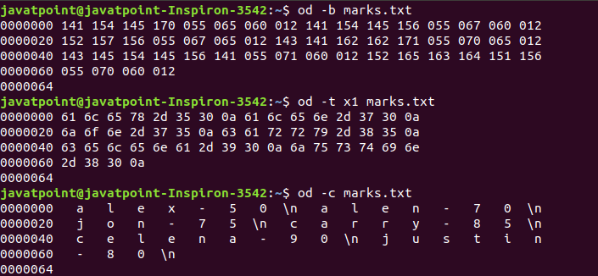

**32. sort Command**

The [sort](https://www.javatpoint.com/linux-sort) command is used to sort files in alphabetical order.

**Syntax:**

1. sort **<file** name**>**

**Output:**

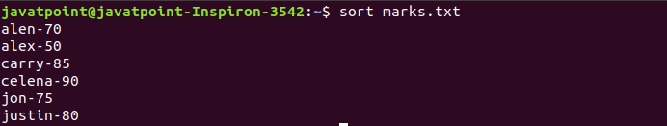

**33. gzip Command**

The [gzip](https://www.javatpoint.com/linux-gzip) command is used to truncate the file size. It is a compressing tool. It replaces the original file by the compressed file having '.gz' extension.

**Syntax:**

1. gzip **<file1>** **<file2>** **<file3>**...

**Output:**

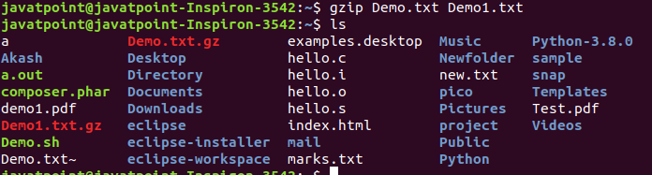

**34. gunzip Command**

The [gunzip](https://www.javatpoint.com/linux-gzip) command is used to decompress a file. It is a reverse operation of gzip command.

**Syntax:**

1. gunzip **<file1>** **<file2>** **<file3>**. .

**Output:**

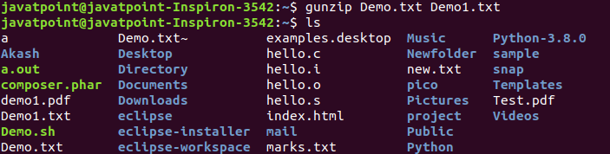

Linux Utility Commands

**35. find Command**

The [find](https://www.javatpoint.com/linux-find) command is used to find a particular file within a directory. It also supports various options to find a file such as byname, by type, by date, and more.

The following symbols are used after the find command:

(.) : For current directory name

(/) : For root

**Syntax:**

1. find . -name "*.pdf"

**Output:**

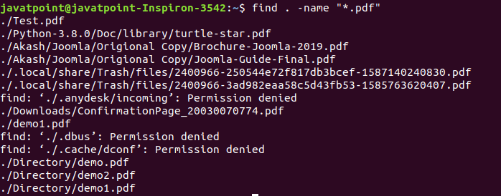

**36. locate Command**

The [locate](https://www.javatpoint.com/linux-locate) command is used to search a file by file name. It is quite similar to find command; the difference is that it is a background process. It searches the file in the database, whereas the find command searches in the file system. It is faster than the find command. To find the file with the locates command, keep your database updated.

**Syntax:**

1. locate **<file** name**>**

**Output:**

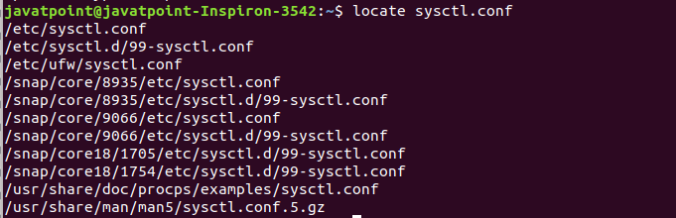

**37. date Command**

The [date](https://www.javatpoint.com/linux-date) command is used to display date, time, time zone, and more.

**Syntax:**

1. date

**Output:**

Linux Commands with Examples

**38. cal Command**

The [cal](https://www.javatpoint.com/linux-cal) command is used to display the current month's calendar with the current date highlighted.

**Syntax:**

1. cal**<**

**Output:**

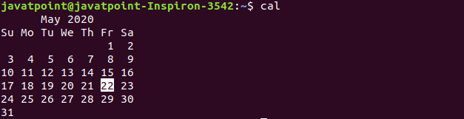

**39. sleep Command**

The [sleep](https://www.javatpoint.com/linux-sleep) command is used to hold the terminal by the specified amount of time. By default, it takes time in seconds.

**Syntax:**

1. sleep **<time>**

**Output:**

Linux Commands with Examples

**40. time Command**

The [time](https://www.javatpoint.com/linux-time) command is used to display the time to execute a command.

**Syntax:**

1. time

**Output:**

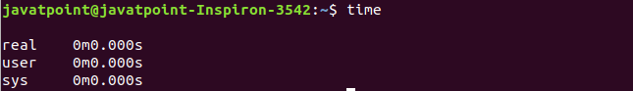

**41. zcat Command**

The zcat command is used to display the compressed files.

**Syntax:**

1. zcat **<file** name**>**

**Output:**

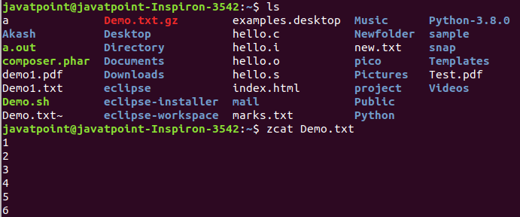

**42. df Command**

The [df](https://www.javatpoint.com/linux-df) command is used to display the disk space used in the file system. It displays the output as in the number of used blocks, available blocks, and the mounted directory.

**Syntax:**

1. df

**Output:**

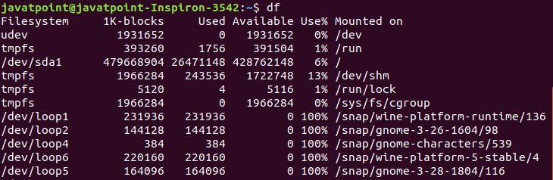

**43. mount Command**

The [mount](https://www.javatpoint.com/linux-mount) command is used to connect an external device file system to the system's file system.

**Syntax:**

1. mount -t type **<device>** **<directory>**

**Output:**

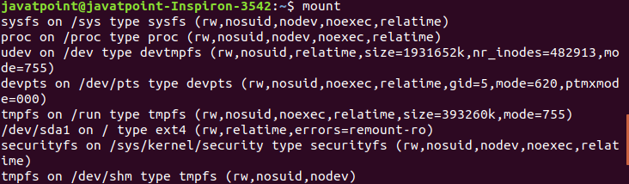

**44. exit Command**

Linux [exit](https://javatpoint.com/linux-exit-command) command is used to exit from the current shell. It takes a parameter as a number and exits the shell with a return of status number.

**Syntax:**

1. exit

**Output:**

Linux Commands with Examples

After pressing the ENTER key, it will exit the terminal.

**45. clear Command**

Linux **clear** command is used to clear the terminal screen.

**Syntax:**

1. clear

**Output:**

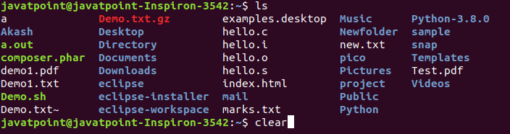

After pressing the ENTER key, it will clear the terminal screen.

Linux Networking Commands

**46. ip Command**

Linux [ip](https://www.javatpoint.com/linux-ip) command is an updated version of the ipconfig command. It is used to assign an IP address, initialize an interface, disable an interface.

**Syntax:**

1. ip a or ip addr

**Output:**

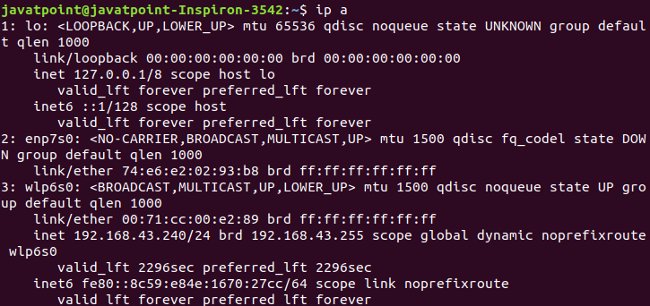

**47. ssh Command**

Linux [ssh](https://www.javatpoint.com/ssh-linux) command is used to create a remote connection through the ssh protocol.

**Syntax:**

1. ssh user_name@host(IP/Domain_name)**</p>**

**48. mail Command**

The [mail](https://www.javatpoint.com/linux-mail-command) command is used to send emails from the command line.

**Syntax:**

1. mail -s "Subject" **<recipient** address**>**

**Output:**



**49. ping Command**

The [ping](https://www.javatpoint.com/linux-ping) command is used to check the connectivity between two nodes, that is whether the server is connected. It is a short form of "Packet Internet Groper."

**Syntax:**

1. ping **<destination>**

**Output:**

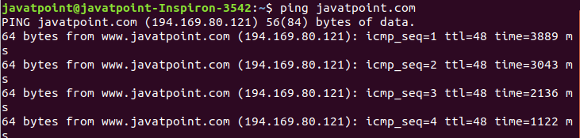

**50. host Command**

The [host](https://www.javatpoint.com/linux-host) command is used to display the IP address for a given domain name and vice versa. It performs the DNS lookups for the DNS Query.

**Syntax:**

1. host **<domain** name**>** or **<ip** address**>**

**Output:**

whoami

It tells you about the system's username.

PlayNext

Unmute

Current TimeÂ 0:00

/

DurationÂ 18:10

Loaded: 0.37%

Â

Fullscreen

Backward Skip 10sPlay VideoForward Skip 10s

**Syntax:**

1. whoami

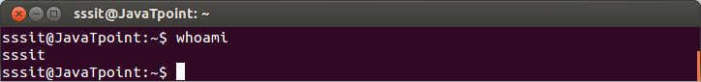

Look at the above snapshot, **'sssit'** is our system's username.

who

The who command gives the information about the users logged on to the system.

**Syntax:**

1. who

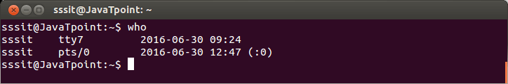

who am i

This command displays the information about the current user only.

**Syntax:**

1. who am i

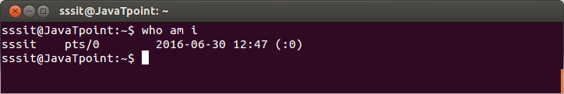

Look at the above snapshot, in our system current logged in user is **sssit**.

w

This command tells about the users who are logged in and what are they doing.

**Syntax:**

1. w

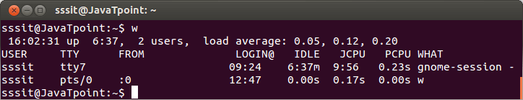

id

This command tells about your user id, primary group id, and a list of groups that belongs to you.

**Syntax:**

1. id

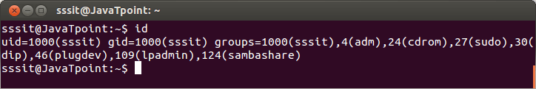

Linux Commands with Examples

**Linux commands in Telegu**

**Ls (list) commands: -**

**ls = list**

**(ls -a) = hidden files chupistundi**

**(ls -a -l) = files and directory’s chupistundi**

**(ll long list) = directory or files ani show avthundi (-rw-r-wrx-x / drwx-r-wr-r)**

**Cat commands: -**

**(cat >file1) = file create chestundi**

**(cat >>file1) = extra content add cheyadaniki**

**(cat file1 >>file2) = Edina extra content add chasty file1 lo, file2 lo copy Cheyadaniki**

**(cat file1 >file2) = file1 lo vuna content file2 lo copy avadaniki**

**(cat file1 file2 >file3) = file1 file2 content copy avthundi file3**

**(cat file1) = content chudaniki**

**(cat /file1) = directory content chudaniki**

**nl command**

**nl file1 = ani lines vunyoo numbers tho chupistundi**

**ex:- 1.hello**

**2.srinu**

**3.nayak**

**Uniq command**

**Uniq file1 = file lo vuna content two times type cheyste like (hello ,hello)voka hello**

**Vuchi one line ni delete cheystundi (remove duplicates of file content)**

**Stat command**

**Stat file1 = command use chasty (access,modify,change) evani chupistundi**

**Touch file1 = file1 time cheyadaniki**

**Touch -a file1 = access time cheyadaniki**

**Touch -m file1 = modify time cheyadaniki**

**Touch command**

**touch = touch command tho multi files create cheyachu**

**touch .file1 = hidden file create cheyadaniki**

**echo command**

**echo “hello” file1 = content rase file name evali (file create cheyadaniki)**

**echo “welcome to my channel” >>file1 = data add cheyali anukunty file1 lo**

**mkdir (make directory) command**

**mkdir means it is a collections of files**

**mkdir dir1 = directory create cheyali ante**

**mkdir -p dir1 dira/dirb/dirc = dir1 lopala subfolders**

**dira-dirb-dirc**

**cd = change directory**

**cd .. = bayatike ravadaniki dir nudi**

**cd ../../.. = multi dir nudi bayatike ravadaniki**

**cd dira/dirb/dirc = direct ga dirc lo ravadaniki**

**pwd (present working directory) command**

**/home/kareem/linux_commands (result)**

**remove command**

**rm file1 = file ni delete cheyadaniki**

**rmdir dir1 = directory file delete cheyali anukonty**

**rm -rf * = forcefully ani files ni delete cheystundi (v.v.imp and danger cmd)**

**copy command**

**cp file1 dir1 = directory one lo copy avthundi**

**move command**

**mv file1 dir1 = file1 move avthundi**

**mv dir1 dirx = directory one lo move avthundi dirx**

**mv dir1 file1 = directory one anadi move avadu file1 lo**

**less and head and tail and tac command**

**less file1 = 1 to 10 lines show cheystundi**

**head file1 = 1 to 10 lines show cheystundi**

**tail file1 = 10 to 1 lines show cheystundi**

**tac file1 = reverse order lo content ni show cheystundi**

**more file1.txt = all content list motham chupistundi**

**editors (vi vim nano)**

|  |  |
| --- | --- |
| **MOVING CURSOR WITHIN FILE** | **INSERTING TEXT** |
| **l - moving cursor towards left** | **i-insert** |
| **h- moving cursor towards right** | **a-insertion begin after cursor** |
| **k-moving cursor up** | **A-insertion begins at end of line** |
| **j-moving cursor down** | **o- inserts new line after cursor** |
|  | **O-inserts new line above cursor** |
| **COPY & PASTE** | **SAVE & QUIT** |
| **yy - copies the current line** | **go to command mode by pressing ESC** |
| **p - paste the copied line** | **:w - to save the content** |
|  | **:w filename - to save the content with filename** |
|  | **:q - quit the file** |
|  | **:q! - quit the file without saving the content** |
|  | **:wq - save the content and quit the file** |

**vi and vim editor = i-press cheyali**

**content include chesi (esc press after :wq enter)**

**nano = content include chesi (control x,shift y enter)**

**grep (global regular expression print) command ----grep so many cmd is there**

**grep root /etc/passwd = root yekkada vundo avani show cheystundi**

**edina word find out cheyali anukunty grep use cheystam**

**grep o file1 = o yekkda yekkada vundo show cheystundi**

**cat /etc/os-release = operating system and version mothom show cheystundi**

**cat /etc/os-rel\***

**sort command**

**sort file1 = alpha betical order lo chupistundi content ni**

**comm command**

**comm file1 file2 = file1 and file2 content ni column lo chupistundi**

**calendar command**

**cal January 2023 = January calendar chupistundi**

**hostname command**

**hostname = e command tho DNS show cheystundi**

**hostname -i = e command tho only ip show cheystundi**

**ifconfig = detail ga ani show cheystundi (ip,dns,region and every thing)**

**yum list installed = ani install ayina packages chupistundi**

**useradd and group command**

**useradd file1 = user create cheyadaniki cmd**

**cat /etc/passwd = user create ayidho ledo check cheyadaniki**

**groupadd file1 = group create cheyadaniki cmd**

**cat /etc/group = group create ayidho ledo check cheyadaniki**

**gpasswd -a user group = single user ni group lo add cheyali anukunte**

**gpasswd -m user1,user2 group = multiple users ni add cheyali anukunnte**

**softlink command**

**ln -s file1 softlinkfile1 = softlink create avthundi**

**file1 lo edina add cheysina content show cheystundi softlinkfile1**

**softlinkfile1 lo kuda edina content add cheyste file1 lo kuda show cheystundi**

**hardlink command**

**ln file1 hardlink1 = hardlink file create avthundi**

**hardlink anadi voka backup file lantide (file1 ni delete cheysina hardlink lo content**

**anadi delete avadu)**

**tar-tape archiver command**

**tar -cvf dir1.tar dir1 = tar file create cheyadaniki**

**gzip dir1.tar = file ni compress cheyadaniki**

**zip file1.zip f1.txt f2.txt f3.txt f4.txt = e cmd tho kuda cheyochu**

**gunzip dir1.tar.gz = unzip cheyadaniki**

**unzip file1.zip = e cmd tho kuda cheyochu**

**tar -xvf dir1.tar = tar remove cheyadanikis**

**wget command**

**wget url echi edina download cheyskovachu**

**chmod command**

**chmod 777 file1 = all persions evadaniki cmd (read-write-permission)**

**chmod 700 dir1 = user ke read and write permissions vastai migetha vatike nill**

**second method**

**chmod g=r,o=rw dir1**

**chmod u=r,g=rwx,o=x file1**

**chmod u+w,g-w,o-r file1**

**chown command**

**chown (user and group name) change cheyali anukunte cmd**